System Design Description (SysDD) Test Producer

**Abstract**

This document provides the main template for the description of Arrowhead Systems technological implementations. In this document the solution for the actual implementation of the System is pointed out.

This document is an optional one. If the actual implementation is not needed, the usage of the System Description document should be adequate to reveal the interfaces and services.

All Arrowhead Systems should be specified using this template and stored on a common repository (available in the SVN Server), in order to document and formalize the pilot demonstrators.

* 1. System Design Description Overview 3

1. Internal structure 3
   1. Decomposition of the System 3
2. Revision history 5
   1. Amendments 5
   2. Quality Assurance 6

## System Design Description Overview

**Table 1 System Information**

|  |  |
| --- | --- |
| **Name** | Test Producer |
| **Owner** | Gustav Hansson |

The Test Producer provides an example on how to create a Producer System using the custom Arrowhead C# Client library.

**Table 2 Pointers to SysD documents**

|  |  |
| --- | --- |
| **System name** | **Path** |
| Test Producer | “./SySD Test Producer.docx” |

## Internal structure

**Table 4 Program files**

|  |  |
| --- | --- |
| Producer | 1. https://github.com/97gushan/arrowhead-client-example/tree/master/producer |
| Client Library | 1. https://github.com/97gushan/arrowhead-client-library |
| Grapevine | 1. https://github.com/sukona/Grapevine |

## Decomposition of the System

This system was developed in C# using the Arrowhead C# Client library. It provides a REST API that is implemented using the Grapevine REST library.

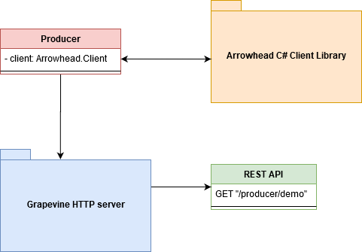

Producer project structure:

Class diagram of the Arrowhead C# Library:

## Revision history

## Amendments

|  |  |  |  |  |
| --- | --- | --- | --- | --- |
| No. | Date | Version | Subject of Amendments | Author |
| 1 | 2020-12-10 | 0.1 | First Draft | Gustav Hansson |
| 2 |  |  |  |  |

## Quality Assurance

|  |  |  |  |
| --- | --- | --- | --- |
| No. | Date | Version | Approved by |
| 1 |  |  |  |
| 2 |  |  |  |